Crypt-Arithmetic Problem
Aim
To implement the Crypt-Arithmetic problem using Python.
Objective
- To solve letter-based arithmetic puzzles.
- To assign unique digits to letters.
- To verify the arithmetic equation.
Algorithm
- Define the words in the puzzle (SEND + MORE = MONEY).
- Extract all unique letters.
- Generate all possible digit assignments.
- Ensure each letter has a unique digit.
- Prevent leading letters from being assigned zero.
- Check whether the equation is satisfied.
- Display the valid solution.

FLOW CHART

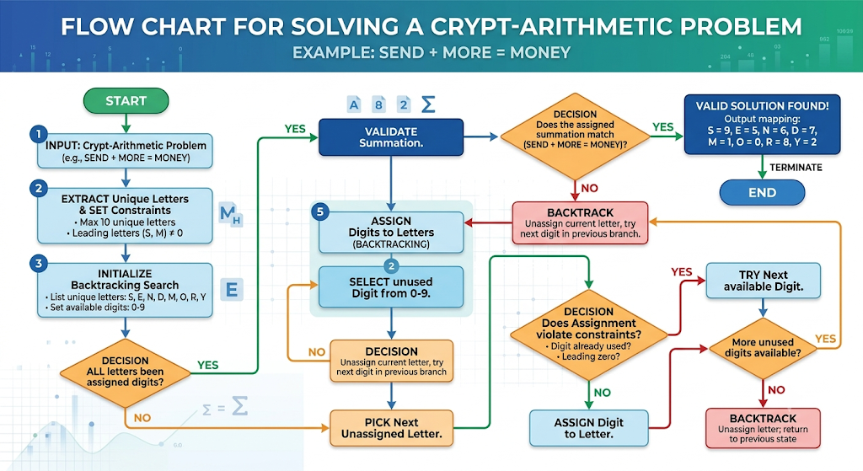
PYTHON CODE
from itertools import permutations

letters = ('S', 'E', 'N', 'D', 'M', 'O', 'R', 'Y')

digits = range(10)

for perm in permutations(digits, len(letters)):
mapping = dict(zip(letters, perm))

# Leading letters cannot be zero
if mapping['S'] == 0 or mapping['M'] == 0:
continue

send = (mapping['S']*1000 +
mapping['E']*100 +
mapping['N']*10 +
mapping['D'])

more = (mapping['M']*1000 +
mapping['O']*100 +
mapping['R']*10 +
mapping['E'])

money = (mapping['M']*10000 +
mapping['O']*1000 +
mapping['N']*100 +
mapping['E']*10 +
mapping['Y'])

if send + more == money:
print("Solution Found")
print(mapping)
print("SEND =", send)
print("MORE =", more)
print("MONEY =", money)
break

RESULT
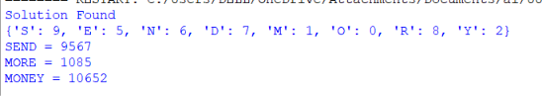V

